DIAGNOSTICAL CHECKS AFTER WAVELENGTH CALIBRATION:
wavelength check:
empty hole, 1 nm increments, 5 replicates
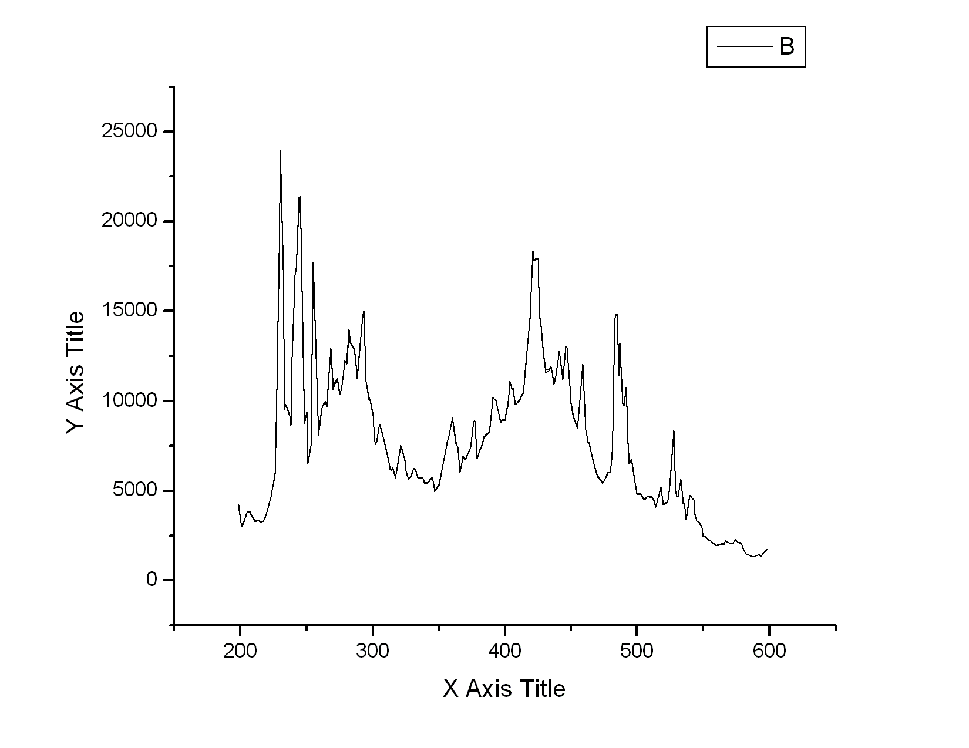
528 nm
230 nm
repeatability of monochromator: five wavelength scans performed in a row, position of peaks:
231/527, 230/527, 230/528, 231/528, 230/528

OD check: maximum at 298 nm (instead of 302 nm)
1 nm increments, 5 replicates; certified 0.6 photometric check solution (not expired), loaded to completely new cell right before the usage
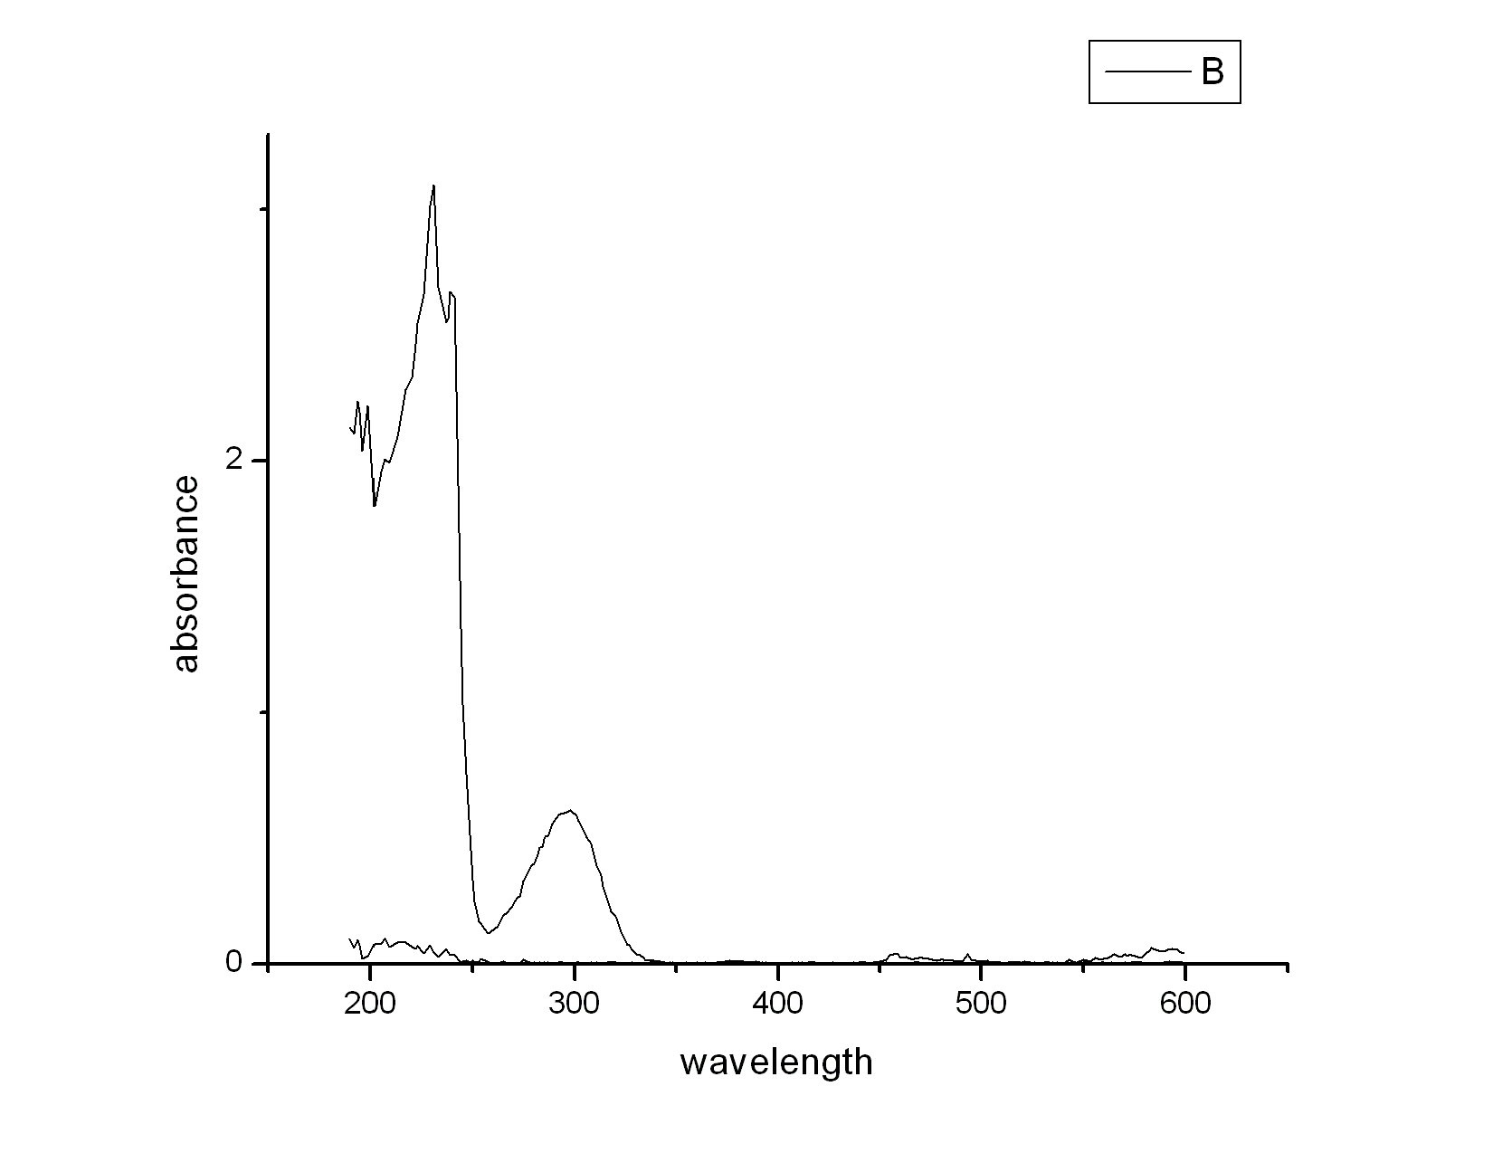
stray light check (9 g/l KCl): absorbance above 1.7 AU, OK
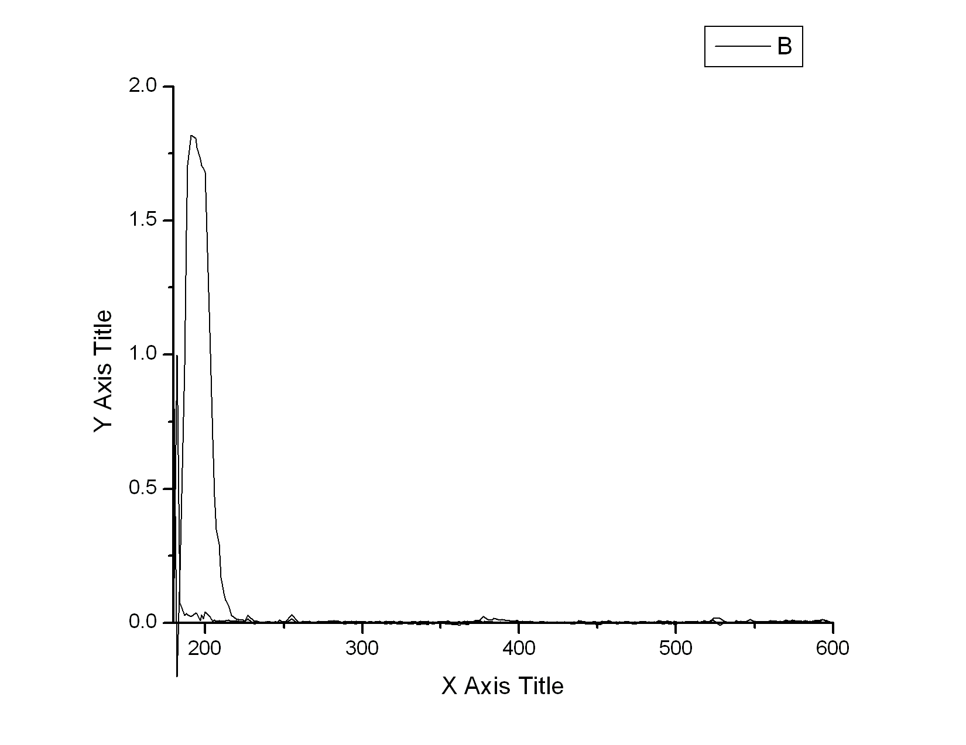
real protein sample: maximum at 275 nm (on classical bentchtop spectrophotometer the sample has the absorbtion maximum at 278-280 nm)
